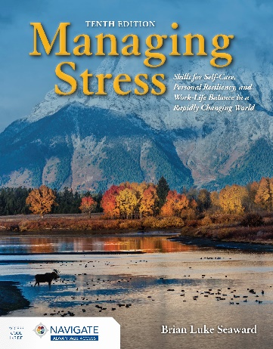
Managing Stress
Skills for Self-Care, Personal Resiliency and Work-Life Balance in a Rapidly Changing World
Tenth Edition
Transition Guide

By Brian Luke Seaward
ISBN-13: 9781284199994
Paperback with Navigate Advantage Access
600 Pages • ©2022

NEW TO THIS EDITION
The topic of stress and stress management (now called resiliency) is quite dynamic, and as such there is always new information to add to the every-growing body of knowledge. Here are some things added to place this tenth edition on the cutting edge of this colossal topic, as well as several new workbook exercises.

Chapter 1: The Nature of Stress
A new section has been included on the topic of Rest and Digest (the opposite physiological conditions of fight or flight). With so much in the news about intense acute stress including the corona virus, fires in California, and countless other situations, a new section has been added on Trauma (“Trauma; Stress on Steroids”).

Chapter 3: The Physiology of Stress
A new section has been added on the vagus nerve, which is responsible for rest and digest.

Chapter 4: Stress and Disease
A whole new perspective on stress and disease has been added through the wisdom of Dr. Joe Dispenza, a big name in the field of mind-body-spirit medicine, with his work on neuroplasticity, as well as the energy centers known as the chakras. Additionally, with a new interview with PNI luminary Kenneth Pelletier, this chapter has a new, updated take on Pelletier’s view of the stress and disease models.

Chapter 6: The Stress Emotions: Anger, Fear, and Joy
A long overdue section on microaggressions has been added to give balance to a population of people often targeted by inappropriate behaviors.

Chapter 7: Stress-Prone and Stress-Resistant Personality Traits
A new section titled “The High-Tech Personality” has been added to describe a stress-prone personality related to constant use of screen devices, leading to an addition.

Chapter 9: Cognitive Restructuring: Reframing
There have been many requests from people who use the book to add the section titled “Stay Above the Fray: Raising Your Vibration.” The focus of this book is a shift from fear-based thoughts and behaviors to compassion-based thoughts and behaviors. This section supports this shift.

Chapter 10: Healthy Boundaries
With the advent of the coronavirus pandemic and its aftermath, with ripples far and wide, a special section has been added regarding behavior changes for adoption.

Chapter 11: Journal Writing
Poetry therapy is an extension of journal writing where one tried to make order out of chaos. This edition addresses this in more detail.

Chapter 12: Expressive Art Therapy
A new section has been added to highlight the popularity of adult coloring books.

Chapter 13: Humor Therapy (Comic Relief)
A long overdue section addressing the topic of inappropriate humor has been added.

Chapter 14: Creative Problem Solving
A new section, “Creativity: Bend, Break, and Blend?” has been added to this chapter, giving a new perspective on cracking the code of the creative process. Additionally, a small section has been added regarding the importance of boredom as a factor in the creative process.

Chapter 17: Additional Coping Techniques
The section on social support groups has been beefed up with a new introduction as well as some new insights regarding the importance of this essential coping skill. A new coping skill, and hence a new section, has been added, titled “Body Tapping: An Emotional Freedom Technique.”

Chapter 18: Diaphragmatic Breathing
As more and more people rely on smartphone apps to help them function throughout the day, a section was added on the topic of apps for relaxing breathing.

Chapter 23: Massage Therapy
New sections on Thai massage and Chinese massage have been added, as well as a short section on the new, calming technique Havening.

Chapter 27: Physical Exercise, Nutrition, and Stress
With an interest in shortcuts to health and fitness, a new section was added to this chapter to address the topic of high intensity interval training (HIIT), as well as some additional research supporting the claims that physical exercise helps ward off the effects of depression.

