TRANSITION GUIDE

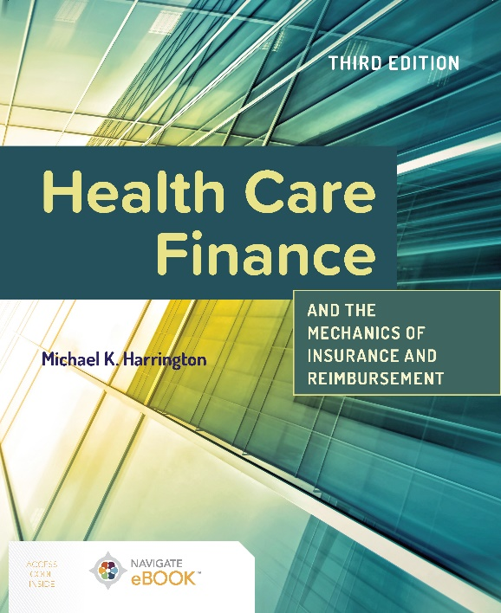

This transition guide serves to outline the updates and new content found in **Health Care Finance and the Mechanics of Insurance and Reimbursement, Third Edition.**

**OUTSTANDING FEATURES**

* Thoroughly covers the methods and process for reimbursement including coding, reimbursement strategies, compliance, financial reporting, case mix index, and external auditing
* Prepares health administration and health information management students with the necessary tools to successfully transition from the classroom to the health care facility.
* Includes a full chapter on the ACA that addresses recent and anticipated future changes that could impact not only the patient but the various health care organizations that provide care in the inpatient and outpatient settings.

**OVERALL REVISION UPDATES**

* Addresses all the new characteristics of the accounting authorities that the health care administrator will have to deal with after the COVID-19 Pandemic.
* New chapter covering the Prospective Payment System (PPS) the Skilled Nursing Facility Patient Driven Payment Model (PDPM)

**APPLICABLE COURSES**

* Healthcare Finance
* Healthcare Administration
* Healthcare Reimbursement in Health Administration
* Health Services Administration
* Nursing Leadership & Management
* Public Health programs

**INSTRUCTOR AND STUDENT RESOURCES**

* Testbanks
* PowerPoints
* Instructor’s Manual

**Connect with JBL**

Blog:

[Health Care Administration](https://www.jblearning.com/blog/-in-category/categories/jones-and-bartlett-learning/health-care-administration)

YouTube:

[youtube.com/@jblearning](https://www.youtube.com/@jblearning)

**Health Care Finance and the Mechanics of Insurance and Reimbursement,**

**Third Edition**

**Michael K. Harrington**

ISBN: 9781284259292

Navigate eBook

© 2024

**CHAPTER OUTLINE**

This chapter outline has been created to help you easily transition to the new edition. Note that chapter content from the prior editionmay now be found in a different chapter*.* Also note that chapter numbers and titles may have changed.

**Chapter 1: Introduction to Healthcare Finance**

This revised chapter on healthcare finance and accounting reflects updated materials for Accounting Authorities, and financial reporting, sources. and uses of financial data.

**Chapter 2: Financial Management**

This revised chapter on financial management reflects updated material on the general accounting principles for a healthcare administrator. Also, the chapter contains information on the differences between healthcare financial accounting and non-healthcare organizations and the impact that COVID-19 had on revenue forecasting for healthcare organizations.

**Chapter 3: Introduction to Claims Processing**

This revised chapter on claims processing features updated materials on clearinghouses, Common Working File, the Qualified Medicare Beneficiary Program, and the Appeal/Denial process with CMS.

**Chapter 4: Government Payer Types**

This revised chapter about government payer types reflects updated materials on all rules and regulations surrounding these payer types.

**Chapter 5: Affordable Care Act and Other Healthcare Reform**

This revised chapter on the Affordable Care Act reflects updated materials on the PPACA along with new material on the 21st Century Cures Act, Information Blocking, Health Information Blocking Exceptions, the Mid-Build Requirement addressing off-campus departments, the Medicare Access and CHIP Reauthorization (MACRA), the new Medicare ID Card and the details surrounding the newly issued card, and Merit-based Incentive Payment System (MIPS).

**Chapter 6: Managed Care Organizations and Non-Managed Care Commercial Insurance**

This revised chapter features updated material regarding managed care organizations and the variety of plans and options for the provider and consumer that are offered in the healthcare marketplace. Also it addresses the essential benefits/coverages offered to individuals and families that are outside the traditional managed care offerings and detailed information on Out-of-Pocket Expenses.

**Chapter 7: Medicare Prospective Payment Systems**

This revised chapter features updated material and information regarding the Medicare Prospective Payment model for all impacted healthcare settings including information on Transfer Payments, High Cost Outlier, and Short Stay Outliers.

**Chapter 8: Hospital Outpatient Prospective Payment System (OPPS)**

This revised chapter features updated material regarding the Medicare Prospective Payment, specifically for the Hospital Outpatient model

**\*New* Chapter 9: Skilled Nursing Facility Prospective Payment System and Consolidated Billing**

This new chapter addresses many of the aspects of the history of the Prospective Payment System (PPS) and goes into detail covering the Skilled Nursing Facility Patient Driven Payment Model (PDPM) identifying all of the characteristics of the PDPM model including but not limited to case-mix adjusted components, Variable Per-diem Adjustments (VPD), AIDS Adjustments, services included and not included in the PDPM model, and a detailed explanation of the Interrupted Stay Policy.

**Chapter 10: Coding for the Non-HIM Professional**

This revised chapter features updated material regarding coding in the inpatient and outpatient settings along with the proper use of Evaluation and Management coding policies.

**Chapter 11: Revenue Cycle Management**

This revised chapter features updated material involving all aspects of the Revenue Cycle in healthcare today including Price Transparency and the processes to be compliant to the new ruling and the chapter covers the No Surprise Act (Parts 1 and 2).

**Chapter 12: Healthcare Fraud and Abuse**

This revised chapter features the combination of two chapters, Healthcare Fraud and Abuse and Recovery Audit Contractors and provides updated information on fraud and abuse in healthcare today. Also, updated materials regarding the OIG and the development of physician practice compliance programs.

**Chapter 13: Government Incentive Programs: Electronic Health Records and Meaningful Use**

This revised chapter features the combination of Meaningful Use, EHRs, and Government incentive programs. This chapter provides updated material on EHRs and the current status of meaningful use and other Government Incentive Programs.

**Chapter 14: The Mechanics of Hierarchical Condition Categories from a CMS Perspective and Lessons Learned**

This chapter reflects the combining of the two HCC chapters on HCC Coding and Lessons Learned into one chapter. The information reviewed in this chapter introduces the healthcare administrator to the basics of Hierarchical Condition Categories and the activities surrounding risk scores, payment, physician involvement, and the grouping that is used in this payment model. Moreover, the chapter addresses the application of hierarchical condition coding and the impact on the physician and accountable care organizations. Also, it demonstrates the impact of coding and documentation and how to best manage this process